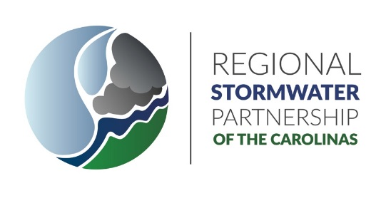

FY 19 Yearly Report

September 19, 2019

Prepared by
Rising Solutions, PLLC

Contents
Overview of Regional Stormwater Partnership of the Carolinas (RSPC) 4
Purpose, Vision, and Goals 4
Mission 4
Background of the RSPC – Beginning as the Regional Stormwater Partnership (RSWP) 4
Today’s RSPC 4
Members 5
Meetings 6
Organizational Structure 6
Official Mailing Address for the RSPC 6
Registered Agent for RSPC 6
Bylaws and Legal Documentation 6
Board of Directors and Officers 7
Committees 7
Executive Committee 7
Non-profit 501c(3) Committee 8
New Members Committee 8
Budget Committee 8
Training Committee 8
Educational Outreach Committee 8
Budget 8
Annual Meeting Fiscal Report – February 13, 2019 8
Dues 9
Expenditures 9
Account Balance Projections 9
Fiscal Year End Report (June 30, 2018) 9
Dues Structure 9
Key Permit-Related Accomplishments in FY19 10
Media Campaign 10
TV 10
Radio 13
Website 13
Grants 15
Water Resources Research Institute – Stormwater Consortium 15
Conferences and Workshops 16
Elected Officials Stormwater Workshop 16
Tech Talk Training Workshops 18
SCAWWA-WEASC Stormwater Lunch and Learn 20
Membership Flyer 20

Overview of Regional Stormwater Partnership of the Carolinas (RSPC)

Purpose, Vision, and Goals
The Regional Stormwater Partnership of the Carolinas (RSPC) provides a forum for collaborations and creates a synergy with 18 municipalities to provide education and outreach activities as part of the EPA’s Clean Water Act Municipal Stormwater permit requirements. The RSPC has developed strong relationships between municipal agencies’ staff by satisfying NPDES requirements and coming together to achieve common goals. It is committed to the betterment of our region through the improvement of water quality and takes an active stormwater leadership role in achieving that vision.

Mission

We seek to educate and bring awareness to the public, local businesses and education centers of our region about stormwater issues and their impact on our water quality and our environment. We further aim to unite local stormwater professionals and stormwater programs by sharing information and ideas in order to collaborate, discuss and address similar stormwater issues on a regional level.

Background of the RSPC – Beginning as the Regional Stormwater Partnership (RSWP)

The Regional Stormwater Partnership (RSWP) was formed through collaboration with stormwater professionals and the Centralina Council of Governments (CCOG) in 2007 with a Clean Water Management Trust Fund Grant. It was developed as a regional stormwater partnership to address our public’s water quality concerns and to implement strategies that protect and promote water quality in our region. The Centralina Council of Governments assumed the lead role in managing the grant by facilitating a regional partnership, fostering local programs, procuring media involvement, and administering the grant disbursements and programs.

In November 2012, the Regional Stormwater Partnership (RSWP) Executive Committee made the joint decision to move the administration of the Partnership from the Centralina Council of Governments (CCOG) to the Infrastructure, Design, Environment and Sustainability (IDEAS) Center at UNC Charlotte. With this move, the RSWP was able to expand its membership beyond the CCOG area and utilize the IDEAS Center resources within the Environmental Assistance Office to further the mission of the RSWP. The RSWP was managed through UNC Charlotte until June 2016.

Today’s RSPC

The Regional Stormwater Partnership of the Carolinas (RSPC) has continued to develop and grow as an organization to support all municipalities throughout the region in satisfying their NPDES municipal stormwater permit requirements. Since July 15, 2017, the RSPC has contracted with Rising Solutions, PLLC consulting engineering firm to provide facilitation services for creating a working relationship with members and an administrative home to the RSPC. This allowed the RSPC to move forward with creating organizational structure to become a 501c(3) Non-Profit, to develop bylaws, hold quarterly and annual meetings, offer training, participate in outreach events, seek grant opportunities, plan workshops, coordinate media campaigns, manage the RSPC website and elect the Board of Directors and Officers. The elected officers are shown in Table 1.

Table 1: Board of Directors - Officers for RSPC
Name - Municipality | Officer Position
Rob Donham – Harrisburg | Chair
Kevin Krouse – Lowell | Vice-Chair
Chris Costner – Monroe | Secretary
Franklin Gover – China Grove | Treasurer
Craig Miller – Charlotte | Member – at – Large

Members
The current RSPC members during FY 2019 includes 18 Municipal and County agencies. These are shown in Table 2.

Table 2: Current RSPC Members FY18-FY19
Belmont | Gastonia | Mooresville
Bessemer City | Harrisburg | Mount Holly
Charlotte | Lake Park | Shelby
China Grove | Lowell | Stallings
Cramerton | Mecklenburg County | Statesville
Dallas | Monroe | Town of Stanley

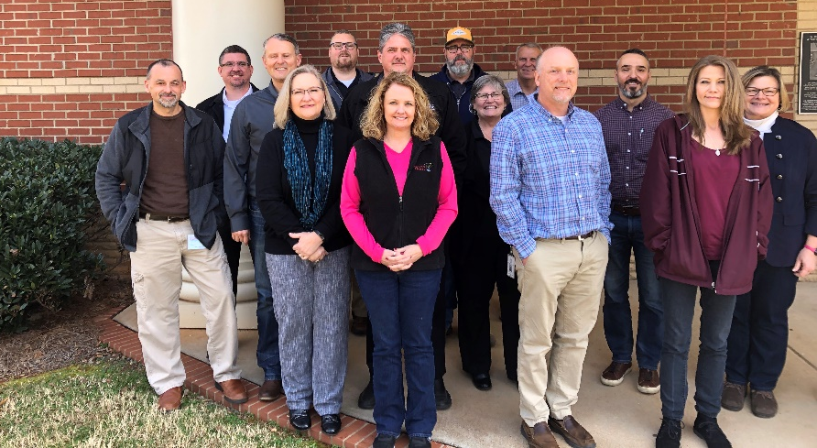
Figure 1: RSPC Membership
Front Row: Maria Stroupe – Dallas, Kim Sturgis – Mt Holly, David Caldwell – Mecklenburg County, Becky Conder – Mt Holly.
Middle Row: Jon Young – Mooresville, Derek Slocum – Statesville, Chris Costner – Monroe, Regina Guyer – Rising Solutions, PLLC, Craig Miller – Charlotte, Cheri Clark – Lake Park.
Back Row: Rob Donham – Harrisburg, Josh Watkins – Cramerton, Chad Waldrup – Belmont, David Johnson – Mt Holly.

Meetings
The 2019 Annual Meeting was held on February 13, 2019 at Gaston College, Kimbrell Campus, 7220 Wilkinson Blvd, Belmont, NC. The 2018 Annual Meeting was held on February 7, 2018 at 2523 Charlotte Hwy, Mooresville, NC 28117.
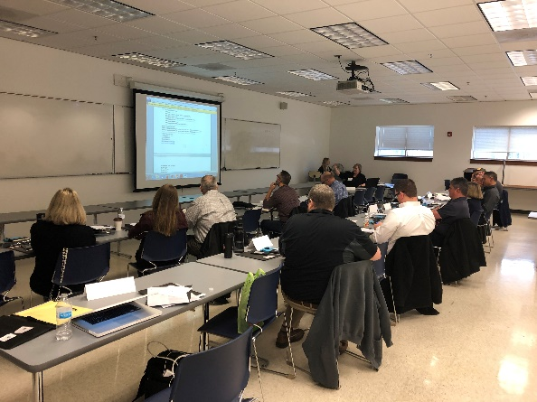
Upcoming Quarterly meetings in 2019 will be held:
- Aug 21, 2019 in Statesville, NC
- Nov 6, 2019 in Harrisburg, NC
Quarterly meetings were held on:
- May 1, 2019 in Charlotte, NC
- November 7, 2018 in Monroe, NC
- August 22, 2018 in Mount Holly, NC
- May 2, 2018 in Statesville, NC
- December 6, 2017 in Belmont, NC
- September 21, 2017 in Charlotte, NC
Figure 2: February 13, 2019 Annual Meeting

Organizational Structure
Non-Profit 501c (3) Organization
The Regional Stormwater Partnership of the Carolinas became Non-profit 501c(3) within the State of NC on 9/28/18 at 3:19pm as noted from NC State Secretary, Elaine F. Marshall. The RSPC submitted Form 1023 and required documents through Robinson Bradshaw law firm to the IRS on March 13, 2019 in seeking to obtain the tax-exempt status. Ty E. Shaffer is the legal counsel for the RSPC whose contact is (704) 377-8142 and email address: TShaffer@robinsonbradshaw.com.

Official Mailing Address for the RSPC
Regional Stormwater Partnership of the Carolinas
6012 Bayfield Parkway - Suite 220
Concord, NC 28027

Registered Agent for RSPC
Rising Solutions, PLLC with Regina C. Guyer, P.E. leadership is the registered agent for the RSPC.

Bylaws and Legal Documentation
The Regional Stormwater Partnership of the Carolinas adopted bylaws and legal documents as listed below during the August 22, 2018 meeting.

Adopted legal documents:
1) Articles of Incorporation
2) Bylaws
3) Consent of Members of RSPC to Action Without Meeting
4) Conflict of Interest Policy
5) Conflict of Interest Annual Disclosure Statement for Board Members
6) Whistleblower Policy
7) Document Retention Policy
8) Memorandum – Guidelines for Meeting Minutes

Board of Directors and Officers
During the 2019 Annual Meeting on February 7, 2019 the Board of Directors and Officers were presented for continued terms. The current Board of Directors and Officers are:
Rob Donham, Chair, RSPC
Town Engineer
Town of Harrisburg
(704) 455-0728
rdonham@harrisburgnc.org

Kevin Krouse, Vice Chair, RSPC
City Manager
Town of Lowell
(704) 824-3518
kkrouse@lowellnc.com

Chris Costner, Secretary, RSPC
Stormwater Engineer
City of Monroe
(704) 282-4537
ccostner@monroenc.org

Franklin Gover, Treasurer, RSPC
Assistant Town Manager
Town of China Grove
(704) 857-2466, extension 106
fgover@chinagrovenc.gov

Craig Miller, QEP, CPSWQ
Member at-large, RSPC
Stormwater Supervisor
City of Charlotte
(704) 336-7605
cmmiller@ci.charlotte.nc.us

Committees
The RSPC established committees to research and develop recommendations to the organization. Committees will be developed as actions are pursued needing investigation, evaluation, and leadership outside of a meeting timeframe. Committees will report back to the RSCP Board and memberships at quarterly and annual meetings. The current active committees include:

Executive Committee
Executive Committee shall consist of the Chair (Rob Donham), the immediate past Chair of the Board of Directors (currently not applicable), Vice-Chairman (Kevin Krouse), Treasurer (Franklin Gover), and Secretary (Chris Costner). The Executive Committee shall meet to consider matters of a nature which cannot wait for action until the next meeting of the Board and shall have all the power and authority of the Board of Directors to act in regard to such matters.

Non-profit 501c(3) Committee
A Non-profit committee was formed with Rob Donham – Harrisburg, Craig Miller – City of Charlotte, Chris Costner – Monroe, and Derek Slocum – Statesville. This committee provides leadership in creating the Non-profit, evaluates and interacts with legal counsel, and executes items needed to finalize the organizational structure.

New Members Committee
The RSPC set up a new members committee to provide leadership and direction in seeking to grow the organization. The committee chair is Derek Slocum – Statesville with Chris Costner – Monroe, David Johnson – Mt Holly as members, and Kevin Krouse - Lowell. During the May 2, 2018 meeting, Craig Miller gave Derek a list of all the regional municipalities who are or who will be designated as MS4 as a focus list of potential new members. Derek will contact RSPC members in proximity to the potential new member and request them to contact the potential member. Information on any potential new members, from website or email inquiries, will be forwarded to the committee.

Budget Committee
A budget committee was developed with Franklin Gover – China Grove (Treasurer and committee chair), David Caldwell – Mecklenburg County, and Chris Costner – Monroe. The committee is evaluating expenditures and revenue from dues to formulate the RSPC budget plans.

New committees were designated during the 2019 Annual Meeting held on February 13, 2019. These were:

Training Committee
A training committee was developed with Rob Donham – Harrisburg as committee chair, Josh Watkins - Cramerton, and Chad Waldrup – Belmont. The committee will provide leadership in developing the spring and fall Tech Talks, workshops, and creating an inventory/database of outreach and educational materials which RSPC members may have available.

Educational Outreach Committee
An educational outreach committee was developed with David Caldwell – Mecklenburg County as committee chair, joined by Cheri Clark – Village of Lake Park, Derek Slocum - Statesville, Chad Waldrup – Belmont, and Jon Young - Mooresville as committee members. Gina Ratajc – Rising Solutions, PLLC to offer committee support as she was an educator and could provide assistance in development of educational plans. The committee will investigate a variety of ways and organizations which the RSPC could collaborate with in seeking to engage students in experiential learning projects with the RSPC members. Ideas discussed were interns, experiential learning projects, grants, work study, involvement with career fair events and / or other venues which community colleges or universities may have available. The overall goal will be in engaging students to develop and provide stormwater outreach and education within each members’ municipality.

Budget

Annual Meeting Fiscal Report – February 13, 2019
The December 31, 2018 ending balance was $131,113.64. The February 13, 2019 annual meeting account balance is $116,704.14.

Dues – The RSPC has collected $64,250 in dues for 2018-2019. This number includes the two new Tier 1 towns (Town of Stanley and Dallas) that recently joined the RSPC.

Expenditures- The RSPC’s FY2019 expenditures are as expected for approximately half of the budget year, totaling $40,119.19. There have been two payments to Rising Solutions, PLLC for facilitation services totaling $19,569 with two equal payments remaining for facilitation services. The Agency has been paid $10,300 for advertisement/media services. The RSPC anticipates $11,200 in remaining media services fees to The Agency. Also, legal fees associated with the partnership total $7525.69 year-to-date. The legal fees incurred during incorporation as a nonprofit were a bit unknown. The Executive Committee expects these charges to greatly reduce as nonprofit and tax-exempt status is obtained.

Account Balance Projections – It is projected that the RSPC will need to use $13,500 in savings to close out this fiscal year, projected spending of $77,608 minus $64,250 in dues collected. There will be approximately $77,000 left in savings in June 2019.

Fiscal Year End Report (June 30, 2018)
During the August 22, 2018 quarterly meeting, the fiscal statement by Treasurer, Franklin Gover, at the end of the fiscal year June 20, 2018, a balance of $92,801.

Dues Structure
The RSPC members voted and approved the dues structure of seven tiers based on population of the municipal entities during the February 2, 2018 annual meeting. Table 3 shows the approved dues structure and the current municipalities within the tiers.

Table 3: Approved Dues Schedule by Tiers Based on Population
Regional Stormwater Partnership of the Carolinas Dues Tiers Established 2-7-18
Tier | Population | Dues | # in Tier | Total from Tier | FY 2019 Municipalities within Tiers
Tier 1 | <5,000 | $750 | 6 | $4,500 | China Grove, Cramerton, Dallas, Lake Park, Lowell, Town of Stanley
Tier 2 | 5,000 - 10,000 | $1,500 | 1 | $1,500 | Bessemer City
Tier 3 | 10,001 - 25,000 | $2,500 | 5 | $12,500 | Belmont, Harrisburg, Mt Holly, Shelby, Stallings
Tier 4 | 25,001 - 50,000 | $4,000 | 3 | $12,000 | Monroe, Mooresville, Statesville
Tier 5 | 50,001 - 100,000 | $5,000 | 1 | $5,000 | Gastonia
Tier 6 | 100,001 - 250,000 | $12,000 | 1 | $12,000 | Mecklenburg Co + Towns
Tier 7 | >250,001 | $17,500 | 1 | $17,500 | Charlotte
Total Projected Dues Collected |  |  |  | $65,000

Key Permit-Related Accomplishments in FY19

Media Campaign
The RSPC worked with The Agency for media campaign productions. Campaigns to promote awareness of regional stormwater issues using an array of marketing strategies were implemented. These included new website development with member connectivity along with the production of radio and television spots.

TV
There were in-studio and in the field spots developed or to be developed for television as well as web-based media and were provided to RSPC membership for use within their municipalities. These provided several opportunities for stormwater outreach to the public and included:
- WCCB, Carolina Insight: Regional Stormwater Partnership of the Carolinas
August 2, 2019 by Caryn Little
Alyssa Dodd, at Charlotte, discusses stormwater infrastructure including that more is being built and what is there sometimes needs to be repaired. She discusses how we contribute resources to help meet the infrastructure needs. In addition, she shares how we can all work together to clear off storm drain, report pollution (Figure 3).

The website link for the interview can be found at:
https://www.wccbcharlotte.com/2019/08/02/carolina-insight-regional-stormwater-partnership-of-the-carolinas/
Figure 3. Carolina InSight with Alyssa Dodd
- WCCB, Rising Spotlight with Derek James: With All the Rain, Here’s How You Can Protect Your Home
January 14, 2019 by Sarah Obeid
Dave Johnson, Public Utilities Director at Mount Holly, discusses stormwater fees and how it benefits homeowners. He also touches on practical ways homeowners can keep rainwater from the foundation of their homes and why streets flood during some rain events and not others (Figure 4). The website link for the interview can be found at:

https://www.wccbcharlotte.com/2019/01/14/rising-spotlight-with-all-the-rain-heres-how-you-can-protect-your-home-from-stormwater-damage/

The RSPC in-studio interview on January 14, 2019 covered four different stormwater topics, shown in Table 4. The focus of the interview was to help residents especially homeowners to understand the stormwater fee, flooding, and how they can help.

Table 4: RSPC January 14, 2019 In-Studio Interview Summary
Part | Verbal
1 | We look at our bill and we see stormwater fee, what is that, and how does it benefit us
2 | Flooding, what are somethings we can do as homeowners to keep that water away from the foundation of the home.
3 | Who owns and maintains the infrastructure and the stormwater facilities
4 | Why do some streets flood during some of these events and then other times you don’t have any flooding at all?

Figure 4. January 14, 2019 In-Studio Interview on Stormwater with Dave Johnson, Mt. Holly
- Rising Spotlight: StormWater Pollution
July 27, 2018 by Kristen Fisher
Stormwater pollution is a big problem here in the Piedmont. City of Monroe stormwater engineer, Chris Costner, has ways on how you can keep our area waterways clean.
https://www.wccbcharlotte.com/2018/07/27/rising-spotlight-stormwater-pollution/
- WCCB Carolina Insight: Storm Water Management
July 23, 2018 by Sarah Obeid
Derek Slocum with the City of Statesville highlights the importance of storm water management and how it can affect your drinking water and the environment around you.
https://www.wccbcharlotte.com/2018/07/23/carolina-insight-storm-water-management/

- Weather Water Week: Keeping Our Lakes and Rivers Clean
July 17, 2018 by Sarah Obeid
Water Week has begun, and we’ll be talking all things water!
Our Rising meteorologist Nicole talked with Charlotte Storm Water Services about our local rivers and waterways and how to keep them clean.
https://www.wccbcharlotte.com/2018/07/23/carolina-insight-storm-water-management/

The Fall 2018 campaign’s Carolina Insight spot was on topics of Asset Management, Funding, and the Changing Infrastructure by the City of Charlotte, but it did not air until August. Thus, the impressions will come with our FY20 campaign. The Spring 2019 campaign also included a Carolina Insight recorded message with Mt. Holly and a Rising Spotlight Live In-Studio Interview with Statesville. Those are currently being scheduled and thus will be with our FY20 campaign.
A summary of the overall Fall 2018 and Spring 2019 TV media reach and Web Based TV media reach is shown in Tables 5 and 6 (before the Carolina Insight). The TV Media outreach included several highlighted articles/interviews as shown in Table 6. In Fall there were 500 TV Media spots which resulted in 4,682,500 impressions. The total web-based TV media impressions were 909,029. Therefore, making an TV media campaign reach in the Fall of 5,591,529. In Spring there were 475 TV Media spots which resulted in 2,905,567 impressions. The total web-based TV media impressions were 469,430. Therefore, making an TV media campaign reach in the Spring of 3,375,045. Therefore, making an overall TV media campaign reach of 8,966,574.

Table 5: TV Media Reach Summary
Date | TV Platform | Number of Paid Spots | Number of Delivered Spots including Public Service Announcements |  | Impressions
9/1/18-11/5/18 | WCCB CW | 157 | 280 |  | 3,649,600
9/1/18-11/5/18 | GCCB MeTV | 88 | 119 |  | 831,300
9/1/18-11/5/18 | HCCB Antenna TV | 72 | 174 |  | 14,400
Fall Total of TV Media Spots: 500 resulting in Total Impressions Of: |  |  |  |  | 4,682,500
4/1/19-5/31/19 | WCCB CW | 157 | 263 |  | 1,830,567
4/1/19-5/31/19 | GCCB MeTV | 88 | 104 |  | 528,000
4/1/19-5/31/19 | HCCB Antenna TV | 72 | 108 |  | 547,000
Spring Total of TV Media Spots: 475 resulting in Total Impressions Of: |  |  |  |  | 2,905,567
FY19 Total of TV Media Spots: 975 resulting in Total Impressions Of: |  |  |  |  | 7,588,067

Table 6: Web Based TV Media Reach Summary
Date | Web Based Platform | Link to Media | Impressions
1/14/2019 | WCCBCharlotte.com | https://www.wccbcharlotte.com/2019/01/14/rising-spotlight-with-all-the-rain-heres-how-you-can-protect-your-home-from-stormwater-damage/ | 288,300
1/14/2019 | Rising News Package |  | 188,625
1/14/2019 | Rising Guest Appearance |  | 44,600
1/14/2019 | Rising Story Streamed |  | 63,854
1/14/2019 | Webstory link |  | 794
Teaser and story links above | Teaser and story links above | Teaser and story links above | 1,900
Teaser and story links above | Teaser and story links above | Teaser and story links above | 224,041
Teaser and story links above | Teaser and story links above | Teaser and story links above | 8,200
Fall Web Based TV Media Reach Total Impressions |  |  | 909,029
4/1/19-5/31/19 | WCCBCharlotte.com | https://www.wccbcharlotte.com/2019/08/02/carolina-insight-regional-stormwater-partnership-of-the-carolinas/ | 188,625
4/1/19-5/31/19 | Rising News Package |  | 28,650
4/1/19-5/31/19 | Rising Story Streamed |  | 794
4/1/19-5/31/19 | Webstory link |  | 1,909
4/1/19-5/31/19 | All Social Accounts | Teaser and story links above | 225,660
4/1/19-5/31/19 | Emailed Weekly | Teaser and story links above | 7,645
4/1/19-5/31/19 | ROS on site & Mobile | PSA Bonus :15 Spots Impressions | 16,147
Spring Web Based TV Media Reach Total Impressions |  |  | 469,430
FY19 Web Based TV Media Reach Total Impressions |  |  | 1,378,459

Radio
The RSPC FY19 media campaign with The Agency included a radio campaign with air dates of September 17-30 and October 8-21 each with 12 messages per week (48 total) for the Fall campaign and air dates of April 8-21 and May 6-21 each with 6 messages per week (36 total) for the Spring campaign. For both campaigns, the messages were during the 5am to 12 midnight time slots. The total impressions for the radio campaign was 444,000 with 249,600 in Fall and 194,400 in Spring.

Website
The Regional Stormwater Partnership of the Carolinas has an interactive website to further the mission of the RSPC. The visitors to the website were analyzed using Google Analytics. During FY19, 2,284 visitors came to the partnership website. 2,271 were new users and 344 were returning users.

The website includes tab headings for:
- HOME
- ABOUT STORMWATER
  - Stormwater Pollution
  - Impacts of Pollution
  - What You Can Do
- REPORT POLLUTION
  - Provides links to each municipality for reporting pollution specific to their area which goes to each RSPC member specific web page providing direct contact information of their stormwater contact along with a button link to the municipality’s website.
  - Reporting pollution can also be done via an interactive map on the Report Pollution page.
- FOR EDUCATORS
- EVENTS
  - Allows for listing of current and past events
  - Provides opportunity to set up a registration page, as shown in Figure 3(Should we change to screen shot for the Elected Officials Workshop?
- RESOURCES
- CONTACT

The website includes a “Members Only” area for RSPC members interaction, creating a capability for sharing of important data, BMP strategies, training, forums, and other information exchange. This area of the website requires a password to access.

This year the website became an active part of the RSPC reach. Contact and website information for all the municipalities were linked in across several places with the website to increase the partnership’s ability to connect citizens directly with their local municipalities for questions or to report pollution. Event information including registration (Figure 5) and after-meeting posting of information became the standard. The website is continually being updated to remain current on all the RSPC’s activities, outreach, training and contact information.

Figure 5 :Registration Page on Website for Elected Officials Workshop
These improvements to the website have increased the number of visitors with peaks happening with our October Tech Talk, February Elected Officials, and April for outreach via NCDEQ workshop and the May Tech Talk. See Figure 6.

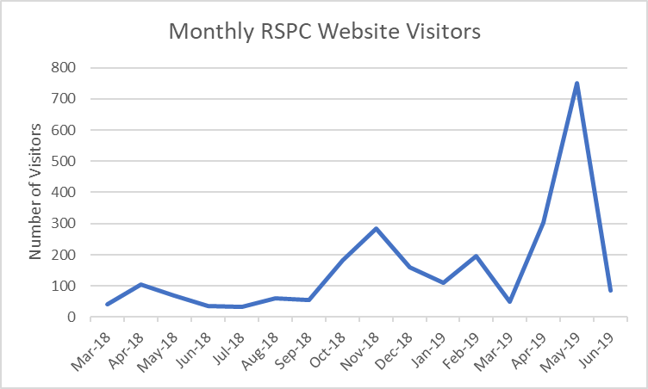
Figure 6. RSPC Website visitors per month

Grants

Water Resources Research Institute – Stormwater Consortium
On November 7, 2018, the Water Resources Research Institute – Stormwater Consortium (WRRI-SWC) issued a Request for Research Concepts: Fostering community engagement and enhancing community-municipal partnerships to address linkages between stormwater and trash, litter and/or illicit discharges in NC Stormwater Group (SWG) member municipalities to receive grant funding. Rising Solutions, PLLC built a grant collaboration with RSPC and Johnson C. Smith University and submitted a research concept on February 11, 2019 titled, Active involvement to develop understanding, build water quality awareness, and implement strategic measures within communities in Charlotte-Mecklenburg to engage citizens toward achieving stormwater program goals and improving water quality. The funding level requested was $75,000.

The project was selected as a top four finalist and the collaborative team presented the research concept to the WRRI-SWC members on June 27, 2019 in Burlington, NC. Dr. Philip Otienoburu – JCSU, David Caldwell – Mecklenburg County, Dr. Kari Raburn and Regina Guyer – Rising Solutions, PLLC attended the meeting, provided a summary presentation, and addressed questions submitted by the SWC members.

On July 2, 2019, Nicole Wilkinson McIntosh notified the research team that:
“The group really enjoyed learning more about the variety of efforts you proposed, and they felt that many of them would help them move forward in their stormwater program management. They unanimously agreed that they would like to move forward with your team to co-develop a full proposal.”
The collaborative team has been requested to develop a final proposal which will be presented to the WRRI-SWC members on September 26, 2019 in Wilmington, NC.

Conferences and Workshops

Elected Officials Stormwater Workshop
The Elected Officials Stormwater Workshop was held on February 28, 2019 from 9am -12:30pm at 2145 Suttle Avenue, Charlotte, NC 28208 on the fourth floor Frazier Fir Conference Room (Figure 7). A flyer was created to highlight the event and speakers which was provided through RSPC members, postal mailings, along with emails to the elected officials from each RSPC member municipality as shown in Figure 8.

Registration
There were 49 people who registered for the Elected Officials Stormwater Workshop with 48 attendees. The category of attendees showed the participants were 35% municipal and government agencies’ elected officials, with RSPC members staff attending comprising 48%, consultants 10%, academia 4%, and nonmember municipalities at 2%.
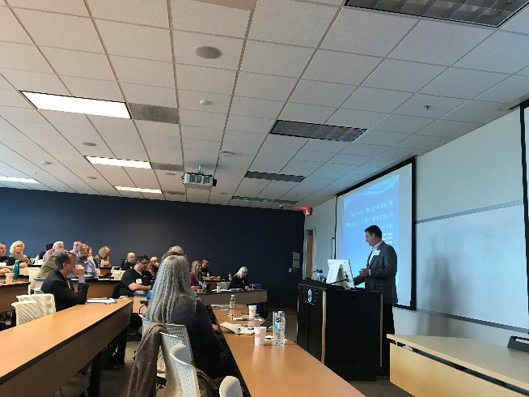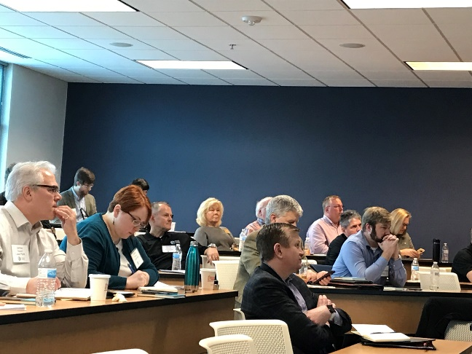
Figure 7: Elected Officials Stormwater Workshop

Summary:
The presentations were meaningful to the elected officials who attended the Stormwater Workshop for Elected Officials in areas of stormwater basics, permit requirements, fees and infrastructure, and control measures. There were dynamic discussions during the interactive panel and audience discussion which covered questions sent in during registration, written in on notecards during the workshop, and asked during the panel. The workshop allowed elected officials to more clearly understand stormwater issues and provide resources for their follow up inquiries through the RSPC and individual members in each municipality. The workshop presentations can be found on the regionalstormwater.org website.

The UNC Environmental Finance Center is a resource on stormwater fees and hosted a webinar on stormwater fees on March 11th, 2019 within which elected officials were invited to join.
https://efc.sog.unc.edu/event/webinar-2019-north-carolina-stormwater-fees-update

Credits:
The types of licenses included:
- 2.5 hours of Professional Development Hours (PDHs) for Engineering

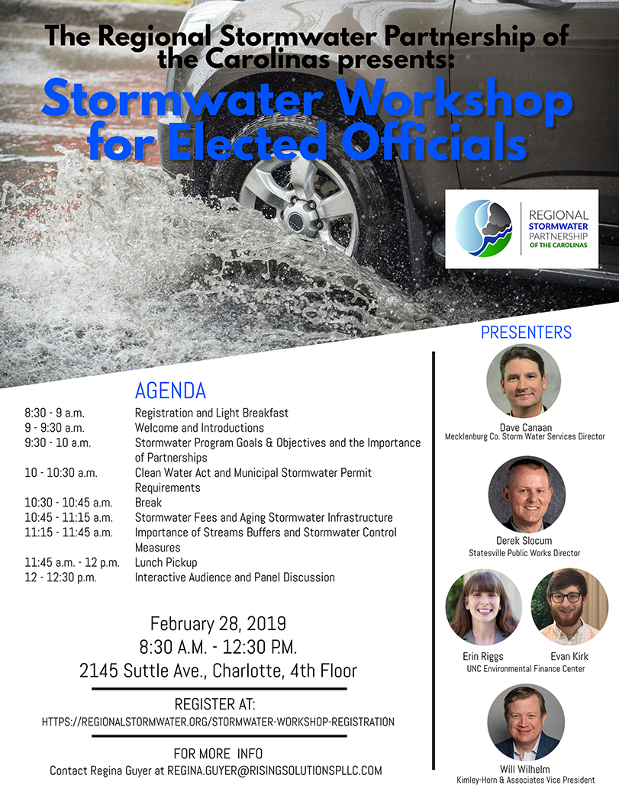
Figure 8: Stormwater Workshop for Elected Officials Flyer

Tech Talk Training Workshops
The RSPC held a Tech Talk, “Managing Stormwater Service Requests from Citizens”, on May 21, 2019 at the Gaston College, Kimbrell Campus located at 7220 Wilkinson Blvd, Belmont, NC (Figure 9). There were 35 registrations for the Tech Talk, with 29 attendees gaining insight and training on management of citizens requests and being responsive. Professional Engineering PDHs were given for six attendees who were professional engineers and signed the registration and PE evaluation forms.

Presentations included:
- Service Requests within the City of Charlotte
By Kevin Herring, City of Charlotte
- Managing Stormwater Service Requests from Citizens
By Andrew DeCristofaro, Mecklenburg County
- City of Monroe Stormwater Maintenance Program
By Chris Costner, City of Monroe Storm Water

These presentations are now available on-line at the RSPC website:
https://regionalstormwater.org/tech-talk-may-2019/

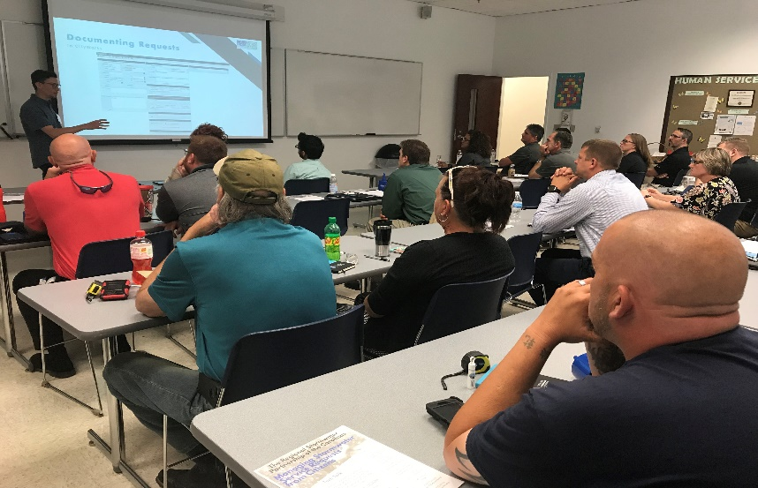
Figure 9: May 21, 2019 Tech Talk - Managing Stormwater Service Requests from Citizens
Andrew DeCristofaro, Mecklenburg County

There were several questions and interactive discussions throughout the workshop. The presentations were followed by an interactive participants discussion with our panel consisting of:
Kevin Herring – Charlotte, Andrew DeCristofaro – Mecklenburg County, Chris Costner - Monroe, Craig Miller – Charlotte, Kevin Krouse – Lowell, Chad Waldrup - Belmont, Franklin Gover – China Grove, and Josh Watkins – Cramerton (Figure 10).
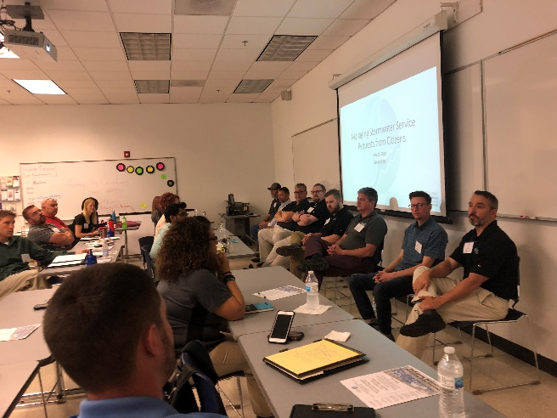
Figure 10: May 21, 2019 Tech Talk Panel - Managing Stormwater Service Requests from Citizens

The RSPC held a Tech Talk, “GIS Mapping for Stormwater Applications”, on October 24, 2018 at the Mecklenburg County Offices located at 2145 Suttle Avenue, Charlotte NC (Figure 11). There were 34 registrations for the Tech Talk, with 27 attendees gaining insight and training on GIS Mapping. There were several questions and interactive discussions throughout the workshop. Professional Engineering PDHs were given for five attendees who were professional engineers and signed the registration and PE evaluation forms.

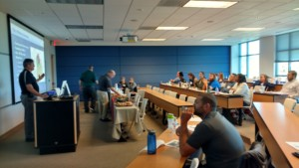
Figure 11: October 24, 2018 Tech Talk - GIS Mapping for Stormwater Applications
Chris Costner, Monroe

Presentations included:
- GIS Applications Supporting Storm Water and Water Quality
By James Scanlon, Mecklenburg County GIS
- Leveraging ArcGIS Applications to Enhance Municipal Stormwater Management
By Neal Banerjee, ESP Associates, Inc Water Resources and Chris Costner, Monroe Stormwater
- Collection of Storm Water Data Using Mobile Operating Systems
By Josh DeMaury, Mecklenburg County Storm Water

These presentations are now available on-line at the RSPC website: https://regionalstormwater.org/events/october-24th-tech-talk/

SCAWWA-WEASC Stormwater Lunch and Learn
The RSPC has developed training opportunities in collaboration with South Carolina American Water Works Association – Water Environment Association of SC (SCAWWA-WEASC) Stormwater through a sponsorship of six Lunch and Learn events. These events were attended by stormwater professionals from both NC and SC with meaningful training and offering of Professional Development Hours.
- June 7, 2019, Duke Energy Catawba Nuclear Station - Nuclear Operations Training Center and Field Tour in the York, SC area from 11am-2pm.
  - Catawba Nuclear Station Stormwater Presentation and Tour, Tina Woodward and Haley Willis of Duke Energy
  - Training of Stormwater Professionals – 16 attendees
- April 5, 2019, Sand Dunes Club, 1735 Atlantic Ave., Sullivan’s Island, SC 29842 - 12-2pm.
  - “Coastal Resiliency and Shoreline Restoration: Evolving the Way We Protect Restored Shorelines,” Ben Nash, Brown and Caldwell
  - Training of Stormwater Professionals – 41 attendees
- February 15, 2019, SCE&G Pine Island Club, Columbia, SC 29212 – 12 – 2pm.
  - “Using Green Infrastructure and Stream Restoration for Stormwater Management and a Way to Create Great Public Spaces” – Will Wilhelm, Kimley-Horn
  - Training of Stormwater Professionals – 54 attendees
- Nov 2, 2018, SCANA, 100 SCANA Parkway, Cayce, SC 29033 – 12-2pm.
  - "Advancing stormwater design standards for the health of our environment, economy, and communities" – William Lamb, Thomas and Hutton
  - Training of Stormwater Professionals – 18 attendees
- August 24, 2018, SCE&G Pine Island Club, Columbia, SC 29212 – 12-2pm.
  - “SC Changes to the 2018 Stormwater Construction General Permit” – Shawn Clark, DHEC
  - Training of Stormwater Professionals – 81 attendees

Membership Flyer
An informational flyer to express the mission, actions, and benefits of the RSPC was developed during FY19. It is shown in Figure 12. David Caldwell, Mecklenburg County; Craig Miller, Charlotte; Derek Slocum, Statesville; and Josh Watkins, Cramerton provided testimonial statements to highlight the benefits of being RSPC members.

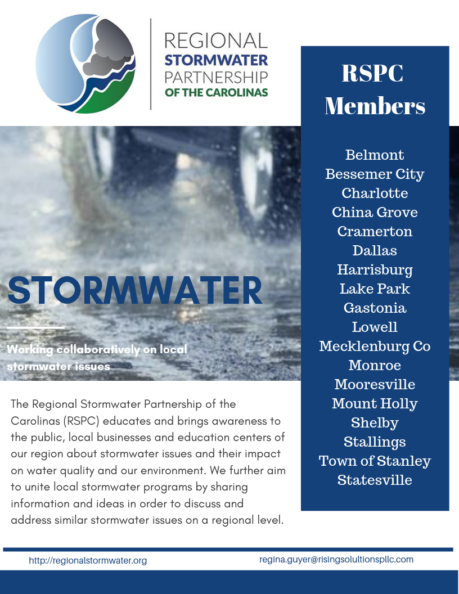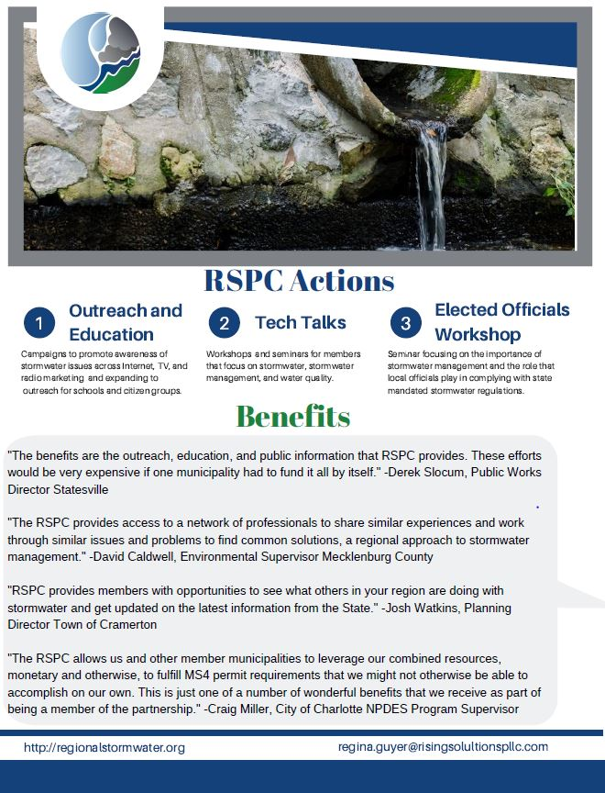
Figure 12: 2019 RSPC Membership Flyer

